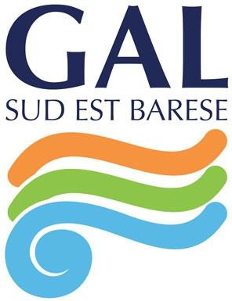
PROGRAMMA ERASMUS +

AZIONE KA121 MOBILITÀ INDIVIDUALE
AI FINI DELL’APPRENDIMENTO - AMBITO VET

“ACCREDITAMENTO GAL SUD EST BARESE”

N°2025-1-IT01-KA121-VET-000328546 –
CUP G41B25000200006

VET LEARNER PROFILE

to be completed in typed form

Name
Surname
Tel
E-Mail
School
Graduation mark
Hobbies
- Choose one of the following training sectors, as provided by the project¹:

  - Tourism/hotel hospitality (catering, reception)
  - Agrarian/ agribusiness
  - Accounting, administration, business management and marketing
- Enter the last 3 job / internship experiences

Order | Year | Duration (months/days) | Job activity | Roles, responsabilities, tasks
Ex. | 2016 | 3 months | Operator telephone marketing | - phone contacts;  - services offer

1 The marked preference is not binding for the trainee in the allocation of the hosting company.


GRUPPO DI AZIONE LOCALE SUD-EST BARESE S.c.a r.l


Via Nino Rota, 28/A 70042 Mola di Bari (BA)
P. IVA 07001380729
Tel. +39 080 4737490
Skype: galseb2010
www.galseb.it info@galseb.it galseb@gigapec.it

- Enter at least 3 desired occupations²

Priority | Area | Name of the Company | Activity
Ex. | Tourism | Travel Agency | Assting clients; flights booking

- Indicate 3 names of businesses (companies, institutions, organizations) in the country and / or city of destination in which you would like to carry out your internship³

Priority | Area | Name of the Company | Activity
Ex. | Catering and  restaurant services | “Royal Restaurant” | Chef - assistant

Place and date Signature
, / /

2 The marked preference is not binding for the trainee in the allocation of the hosting company.
3 The marked preference is not binding for the trainee in the allocation of the hosting company.

